**The Sequoyah Payment file not created:**

1. Log into 106.11
2. Look for the “TRN File DownLoad for Group 10” email, this email gets generated little after 1:00am.

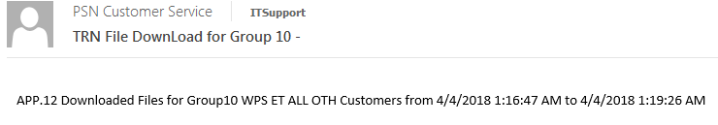

1. If there’s no email found then open the Task Manager, click the Details tab, right-click any column name and choose Select Columns. In the popup window, scroll down until you see Command Line. Click the check box to select it and click OK. You should now see the Command Line column. If Sequoyah is still running, then you see a c:\windows\syswow64\cscript.exe d:\PSNscripts\**Downloadload_Customer_File_Group10.vbs.** The examplebelow shows a different script but the idea is the same.

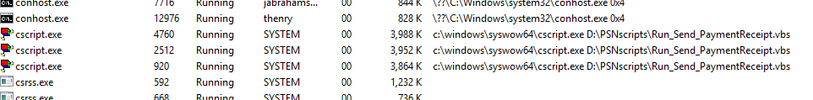

1. If the above script is not running, then manually run the script as shown below.

